- Select all that apply. Which of the following are the primary lymph organs?
  - Thyroid
  - Thymus
  - Bone Marrow
  - Spleen
- What are specialized lymph capillaries present in intestinal mucosa that absorb fat?
  - Lacteals
  - Larger lymphatic vessels
  - Lymphatic capillaries
  - MALT
- True or False: The Thoracic duct drains a majority of the body.
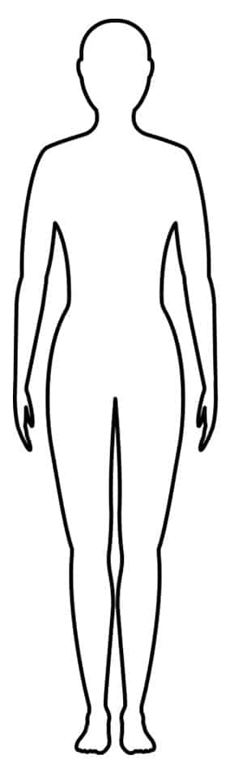
- Where do the lymphatic ducts empty to?
  - Capillary circulation
  - Arterial circulation
  - Lymphatic circulation
  - Venous circulation
- In order, how does lymph travel through the vessels to return to circulation?
Lymph capillaries, lymph collecting vessels, lymph trunks, lymph ducts
- The lymph system is a ______ pressure system.
  - High
  - Low

- Which lymphocytes secrete antibodies?
  - T cells
  - B cells
  - Plasma cells
  - Dendritic cells
- What is an APC?
Cells that activate third LOD by covering themselves in pieces of a pathogen
- Which support cells phagocytize foreign substances and help activate T cells?
  - T Cells
  - B cells
  - Macrophages
  - Dendritic cells
- What fibers are used as stroma in lymphoid organs?
  - Elatin
  - Collagen
  - Dense irregular connective tissue
  - Reticular fibers
- What is a primary lymphoid organ?
  - Where lymphocytes mature
  - Where support cells mature
  - Where lymphocytes are activated
  - Where lymphocytes are transported
- All lymphocytes are produced in bone marrow, and some travel to become T cells.
  - True
  - False
- What is the role of lymph nodes?
  - To filter out red blood cells
  - To dispose of old platelets
  - To store iron
  - To filter lymph and activate immune system
- Where does lymph enter a lymph node?
  - Cortex
  - Medulla
  - Afferent lymphatic vessels
  - Efferent lymphatic vessels
- What can be found within the cortex of a lymph vessel?
  - T cells in transmit
  - Germinal follicles
  - Dividing B cells
  - All of the above
- What has the role of disposing old red blood cells and platelets and storing their products for later use? (Very blood rich)
  - Lymph nodes
  - Liver
  - Spleen
  - MALT
- The red pulp of the spleen is where the immune function occurs.
  - True
  - False
- What portion of the MALT functions to gather and remove pathogens in food or air?
  - Peyer’s patches
  - Tonsils
  - Appendix
  - Thymus
- What is the thymus’s only function?
Train T-Cells
- What is considered the second line of defense?
  - Skin
  - Mucous membranes
  - B cells
  - Fever
- Where would you find “dermacidin” in the first line of defense?
Sweat glands/sweat
- What is it called when a phagocyte that has already consumed a pathogen binds to a lysosome?
  - Phagocyte
  - Phagosome
  - Phagolysosome
  - Phagolysopathogensome
- Natural killer cells are phagocytic.
  - True
  - False
- What is not a cardinal sign of acute inflammation?
  - Redness
  - Heat
  - Fever
  - Pain

- What will occur in the inflammatory response when histamine is released?
  - Vasoconstriction
  - No WBC migration
  - Systemic swelling
  - Vasodilation and attracts WBCs
- What is the role of the interferon?
For virally infected cells to stop other cells around it from getting infected
- Where do pyrogens act to produce a fever?
  - Pituitary gland
  - Cerebrum
  - Hypothalamus
  - Cerebellum
- Humoral immunity acts on ______________ targets.
  - Extracellular
  - Cellular
- What are complete antigens?
  - Haptens
  - Anything seen as foreign that have both immunogenicity and reactivity
  - Anything seen as foreign that has immunogenicity but no reactivity
  - Anything seen as foreign that has reactivity but no immunogenicity
- What will occur if a cell reacts in negative selection?
Apoptosis
- What does a CD4 mature into?
Helper, regulatory, memory
- What does a CD8 mature into?
Cytotoxic
- Which of the following cells do not have a Class 1 MHC protein?
  - Dendritic cell
  - Macrophage
  - RBCs
  - Neutrophils
- Which naive T cell will react with the presentation of a Class 2 MHC protein?
  - CD4
  - CD6
  - CD8
  - CD10

- What must occur for a T Cell to become activated?
  - Antigen binding
  - Antibody binding
  - Co-stimulation
- What cells orchestrate the response, and without them, there would be no response?
  - Cytotoxic T Cell
  - Helper T
  - Regulatory T
  - Memory T
- What cell “dampens” the immune response?
  - Cytotoxic T
  - Helper T
  - Regulatory T
  - Memory T
- What is the role of the kidneys?
  - Produce renin and erythropoietin
  - Ensure long-term acid-base balance
  - Inactivating vitamin D
- What layer of support tissue is a transparent capsule and prevents the spread of infection to kidneys?
  - Renal fascia
  - Perirenal fat capsule
  - Fibrous capsule
  - Pleura
- In order, what is the flow of urine?
Renal pyramid, minor calyx, major calyx, renal pelvis, ureter, bladder, urethra
- What are the most basic and functional unit that form urine?
  - Kidney
  - Major calyx
  - Renal cortex
  - Nephrons
- What is filtrate made up of?
  - Blood plasma plus proteins
  - Blood plasma plus lymph
  - Blood plasma minus proteins
  - Lymph minus proteins
- What part of the nephron makes filtrate?
  - Nephron
  - Glomerulus
  - Nephron loop
  - Proximal convoluted tubule
- What cells are found in the glomerular capsule that form filtration slits?
  - Podocytes
  - Osteocytes
  - Chondrocytes
  - Beta cells
- The Proximal convoluted tubule is _______ dense in microvilli than the Distal convoluted tubule.
  - More
  - Less
- Which limb of the nephron loop is usually thinner and is made up of simple squamous epithelium?
  - Distal convoluted tubule
  - Descending limb
  - Ascending limb
  - Proximal convoluted tubule
- Which nephron type is more abundant?
  - Cortical
  - Juxtamedullary
- Which nephron is associated with vasa recta rather than peritubular capillaries?
  - Cortical
  - Juxtamedullary
- Which cells of the JGC are used to pass signals between 2 other cells?
  - Granular
  - Mesangial
  - Macula densa
  - JG cells
- Which cells of the JGC have mechanoreceptors and are used to sense blood pressure (and contain the enzyme renin)?
  - Granular
  - Mesangial
  - Macula densa
  - Osteocytes
- Which cells of the JGC have chemoreceptors and are used to sense NaCl concentrations in filtrate?
  - Granular
  - Mesangial
  - Macula densa
  - Osteocytes

